**27th sep**

* Downloaded Appium studio.
* Installed it and try to open it.
* Connected my phone with the system and turned on the developer option and debugging mode.
* Tried to install a default application from the Appium studio to my mobile.
* Facing problems and after so many tries also getting error.
* 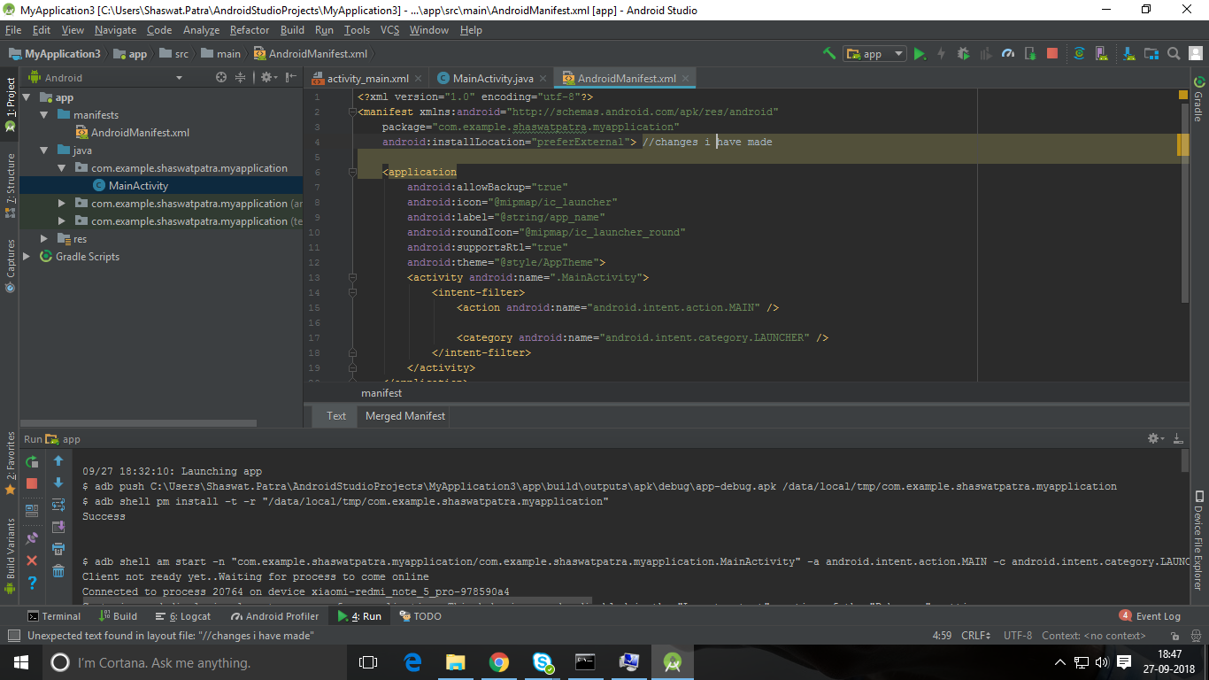Searched in google “how to resolve that specific problem” but it was not resolved.
* Then I tap on File --> setting --> Build, execution, deployment --> Instant run --> disable (Enable instant run …….).
* Changed some code in “Main_activity file”.
* Set path for android studio in environmental variable.
* Still facing the same problem that the application can’t be installed as the user denied.
* Then I have allowed USB installation from my device and the code run and the APP got installed.

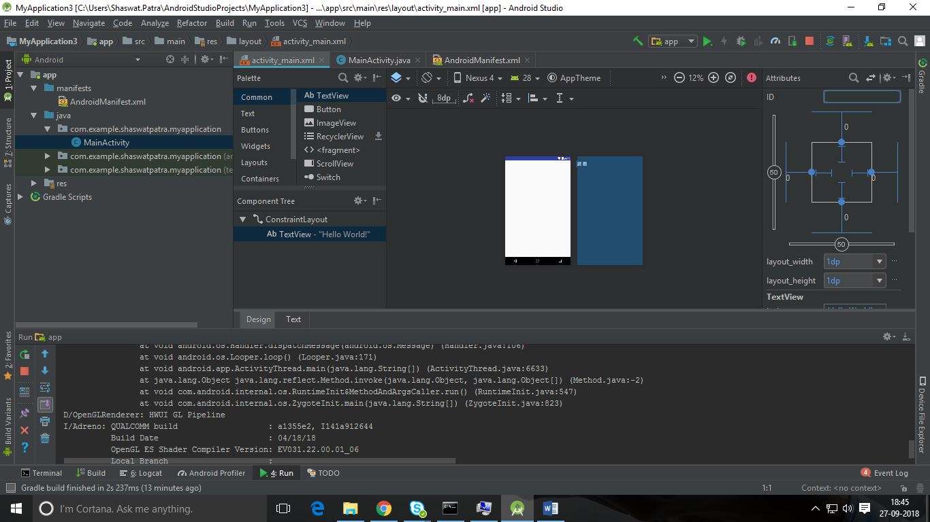

C:\Users\Shaswat.Patra\AppData\Local\Android\Sdk\tools\bin